**Supplementary data 1 - Statistic T tests made on the values basis of Rainfall, Humidity 7.5 cm, Humidity 22.5 cm, Temperature 7.5 cm, Temperature 22.5 cm. Statistically significant differences are highlighted within each comparison text. Significance levels: \*p < 0.05; \*\*p < 0.01; \*\*p < 0.001.**

Part I - Rainfall : The difference of rainfall in L/m2 is not significative between the different sampling times.

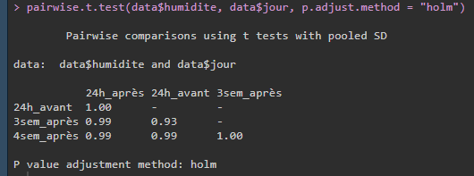

Part II – Humidity 7.5 cm : The difference of humidity in % is significative between 24 hours after and 3 weeks after spreading (p<0.01\*\*), 24 hours before and 3 weeks after spreading (p<0.001\*\*\*), 24 hours before and 4 weeks after spreading (p<0.01\*\*).

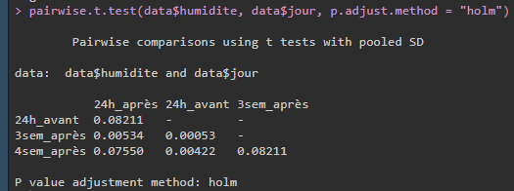

Part III – Humidity 22.5 cm : The difference of humidity in % is significative between 24 hours before and 3 weeks after spreading (p<0.01\*\*), 3 weeks after and 4 weeks after spreading (p<0.05\*).

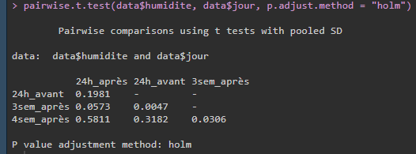

Part IV - Temperature 7.5 cm : The difference of temperature in °C significative between 3 weeks after and 4 weeks after spreading (p<0.01\*\*).

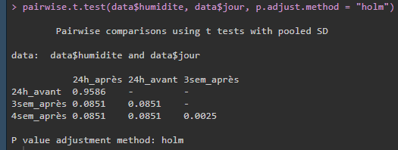

Part V - Temperature 22.5 cm : The difference of temperature in °C is significative between 24 hours before and 3 weeks after spreading (p<0.05\*), 24 hours before and 4 weeks after spreading (p<0.05\*), 24 hours after and 3 weeks after spreading (p<0.05\*), 24 hours before and 4 weeks after spreading (p<0.05\*), 3 weeks after and 4 weeks after spreading (p<0.001\*\*\*).

